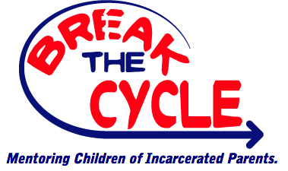

230 Diamond Spring Rd • Denville, New Jersey 07834 • (973) 784-4900 x 113 • (973) 784-4904 (Fax)
GUARDIAN CONSENT FORM
Dear Parent/ Guardian,
Your child has been referred to participate in the Amachi-Break the Cycle Mentoring Program. In the program, your child will be matched with an adult mentor who will meet with them minimally once a week for at least one hour for the term of one year. The volunteer will act as another role model fostering a healthy and supportive relationship.
According to Public & Private Ventures of Philadelphia, children of prisoners are six times more likely than other children to be incarcerated at some point in their lives. A positive mentoring relationship can result in improved school performance, self-confidence, and greater hope for the future.
(Please complete the information below and return this page to contact information listed above.)
Parent/Guardian’s Name ______________________________________________________________________
Child’s Name ________________________________________________________________________________
Street Address:_______________________________________________________________ Apt. No. ________
City___________________________ State_______ Zip Code ____________________ County_______________
Home Phone_______________________________ Cell Phone _______________________________________
Guardian’s Email Address______________________________________________________________________
I hereby certify that I am the parent and/or lawful guardian of the child named above. I hereby give my permission for the child named above to participate in the Amachi-Break the Cycle Mentoring Program. I understand that all mentors have undergone a criminal background clearance.
I understand that the program mentor may be in contact with my child with my child a minimum of one hour per week by phone, e-mail, or personal visitation. I will work with the assigned mentor to determine the most suitable time and arrangements.
I agree to not hold Amachi-Break the Cycle or its volunteers liable for any illness, injury, or accident, which may occur on these outings. I hereby authorize the Amachi-Break the Cycle staff/volunteer to obtain appropriate emergency medical attention for the above-named child should attention be required while I am unavailable for contact at the telephone number(s) listed above.
I understand that I can request that my child be reassigned a new mentor at any time or withdraw my child from the mentoring program at any time.
Parent/Guardian Signature ______________________________________________________ Date _________________

